

 | 
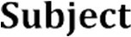 | 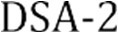
 | 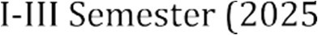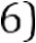
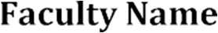 | MD Razia
 | P. Teja
 | 2520030569
 | CSE
 | Co-3

Case Study topic: Smart Logix-logistics & supply chain optimization

Work Done Summary:
In this case study, we implemented an • Gathered business requirements from logistics and supply chain stakeholders.
• Identified pain points in transportation, warehouse operations, inventory tracking, and delivery management.
• Defined system workflows and optimization objectives.

Implementation Details:
- Represented power stations as graph vertices.
- Represented transmission lines as weighted edges.
- Applied Kruskal's Algorithm to construct the MST.
- Sorted edges based on transmission cost.
- Used Union-Find for cycle detection.
- Connected all power stations with minimum cost.
- Calculated the total optimized network cost.

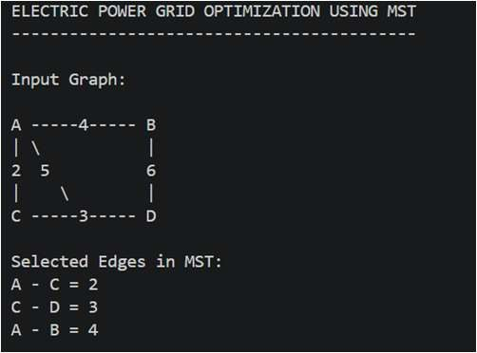
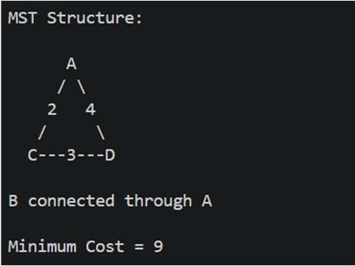
Results and Screenshots:
The Electric Power Grid Optimization System was successfully implemented using Kruskal's Minimum Spanning Tree algorithm. The MST connected all power stations with the minimum transmission cost while avoiding cycles. The optimized network achieved a minimum total cost of 9 units.

GitHub Link: https

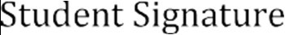 | 